**Trial setup WebRTC with Wowza Streaming Engine in Local System:-**

**System Hardware requirement:-**

Hardware, Minimum recommended production

Disk: 25GB single disk,CPU: Single quad core, 3.00 GHz or better

RAM: 4GB,Network (Audio only): 100Mbps Ethernet

Network (Video Streaming): 1Gbps Ethernet,High load recommended production

Disk: 2 or more in RAID 0 (striping) or SSD, CPU: Dual quad-core or a single hex-core, 3.00 GHz or better, RAM: 16-32GB, Network (Audio only): 1Gbps Ethernet,Network (Video Streaming): 10Gbps Ethernet

**Media Service Requirements**

1. Get a Wowza Streaming Engine To use Wowza Streaming Engine™ software, you need a valid license. You can: Register for a free standard trial or developer trial to receive a trial license key by email.

Purchase a monthly, annual or perpetual license.

Chose the wowza software on base your Operating System. Like

**Windows OS installation:**- To install Double-click the WowzaStreamingEngine-4.7.6-windows-installer.exe installer file and follow the onscreen instructions.

**Mac System:-** To install Open WowzaStreamingEngine-4.7.6-osx-installer.dmg.Double-click the installer package icon and follow the onscreen instructions.

**Linux System :-** To install sudo chmod +x WowzaStreamingEngine-4.7.6-linux-x64-installer.run, sudo ./WowzaStreamingEngine-4.7.6-linux-x64-installer.run, Follow the onscreen instructions.

Link for Wowza Application :- <https://www.wowza.com/downloads/WowzaStreamingEngine-4-7-6/WowzaStreamingEngine-4.7.6-linux-x64-installer.run>

**wowza steam engine default location :-** /usr/local/WowzaStreamingEngine-4.7.5/

Note :- Every changes in Wowza steam engine required to restart the wowza steam engine.

**Command to start or stop the Wowza steam engine**:-

sudo service WowzaStreamingEngine start

sudo service WowzaStreamingEngine stop

To run Wowza™ Transcoder on Windows Server 2008 or 2012 the following components are required: .NET Framework 3.5.1 Desktop Experience

Audio: Opus, Vorbis, PCMU, PCMA

1. https://www.wowza.com/downloads/user/5b630b395380e/WowzaStreamingEngine-Update-4.7.6.zip

WebRTC Preview AddOn package contents

The WebRTC AddOn package includes the following folders and files:

html/publish: HTML example of WebRTC publishing

html/play: HTML example of playing WebRTC content

html/chat: HTML example of WebRTC chat

Requirements :-

1. Wowza setup we had required Wowza key and key is available for 30 day, for the key we had create account in wowza portal, The information we had to share in the wowza steam engine”First Name, Last name, email id, company name, and Password.
2. After the confirmation of Wowza email, we can login in wowza portal. And download the Wowza steam enginee as OS”Linux, Windows, Mac”.

1. **WebRTC with Wowza Streaming Engine Web URL:-**

https://www.wowza.com/docs/how-to-use-webrtc-with-wowza-streaming-engine

Note: - Please restart the webrtc Application for changes to take effect. Then you'll need to record the _720p,_360p,or _160p and also other stream.

**Append steam wowza steam engine :-** You need to edit [install-dir]/conf/webrtc/Application.xml and go to the <Streams> section:  
  
Change:  
<StreamType>live</StreamType>  
  
To:  
<StreamType>live-record</StreamType>  
  
While still in the Streams section move down to the <Properties> section to add the following:  
  
<Property>  
<Name>appendFile</Name>  
<Value>true</Value>  
<Type>Boolean</Type>  
</Property>  
  
Save and restart your application for changes to take effect.

**Nat system with wowza steam engine:-**  You will need to have port forwarding with the below ports from 202.16.15.26 -> 192.168.1.200:

TCP: 1935, 443, if using the sample web server 9443

UDP: 6970 - 9999 (if using UDP)

Then your StreamLock or SSL cert will need to point to 202.16.15.26

In your [install-dir]/conf/webrtc/Application.xml you will need to set your external IP:

<Property>

<Name>webrtcIceCandidateIpAddresses</Name>

<Value>202.16.15.26,udp</Value>

<Type>String</Type>

</Property>

Note :- Amazon EC2 security groups for EC2 Linux instances.

On the Configure Security Group page, select the option to create a new security group, and then fill out the form to define the firewall rules for your instance in the selected region. For the purposes of this guide, add rules to open port 1935 in the firewall for RTMP streaming and the port range 8086-8088 for Wowza Streaming Engine Manager. To do this for RTMP / WEBRTC streaming, click Add Rule, select Custom TCP rule for the Type, enter 1935 in Port Range, and select Anywhere in Source. Repeat this step to enable the port range 8086-8088. For more information about additional rules to add for streaming and for managing the Streaming Engine software.

After The all configuration in local:- the web link:- 192.168.*.*8088 /enginemanager/Home.htm

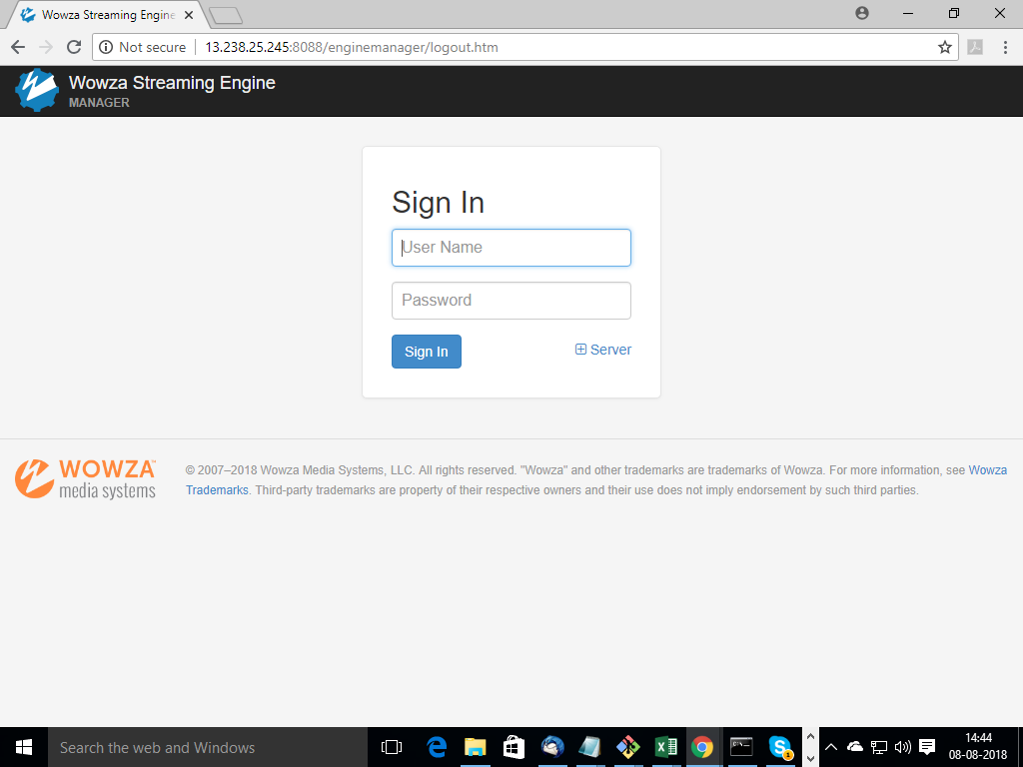

After the login Home page show the status and basic information show:-

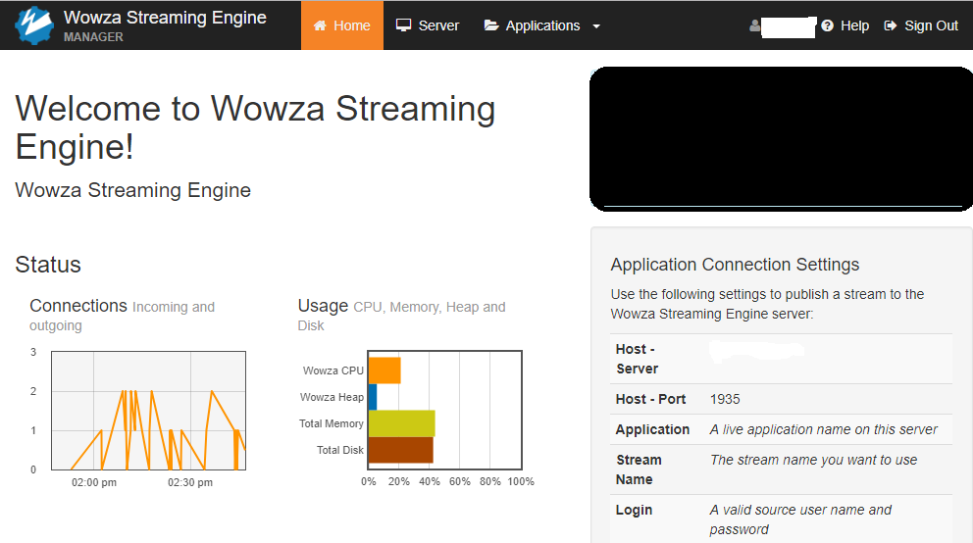

Server Tab show the information license and other information:-

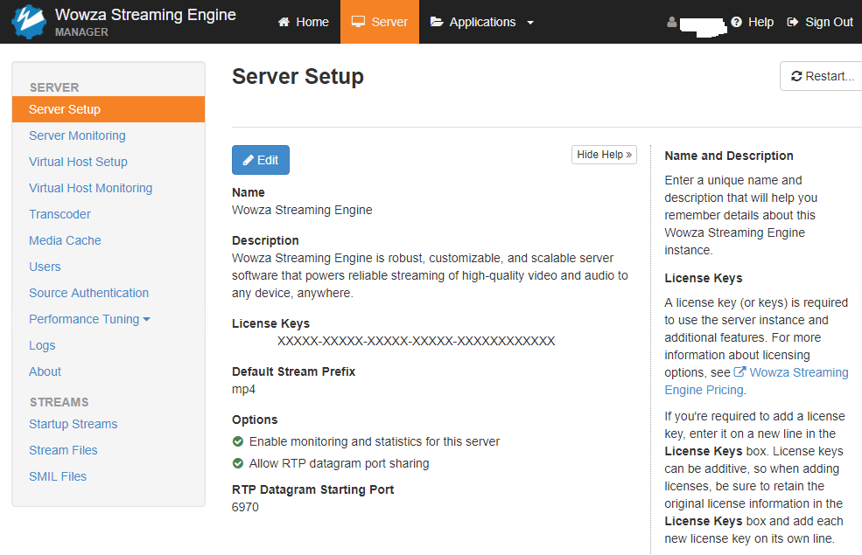

Application Tab:- used for enable disable and edit the options

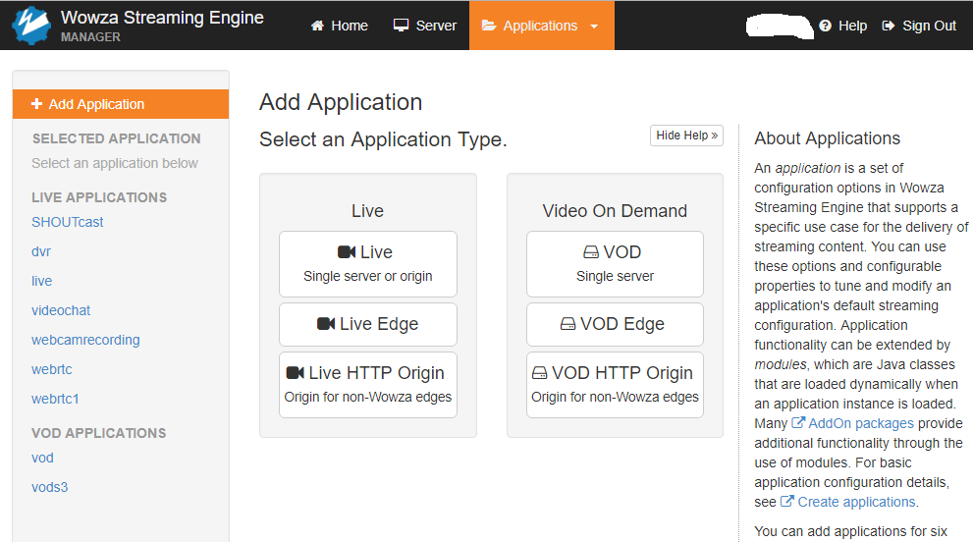

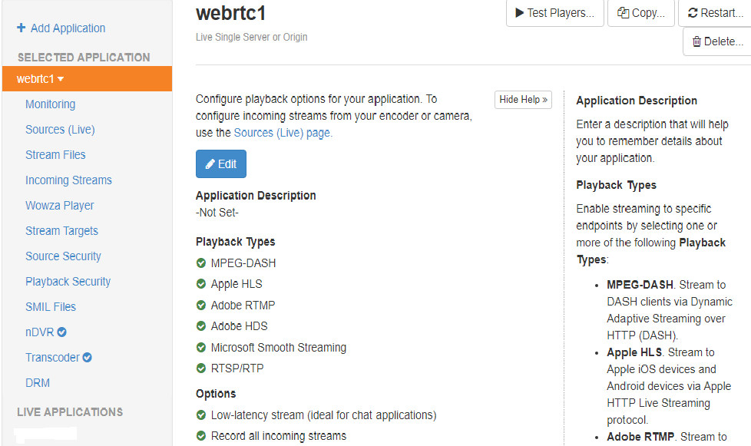

**Gocoder App**:- Install the gocoder app for test the wowza steam videos

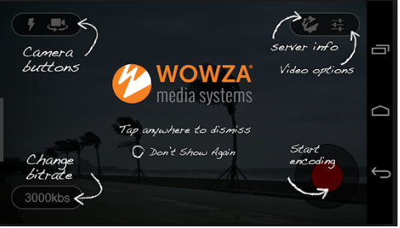

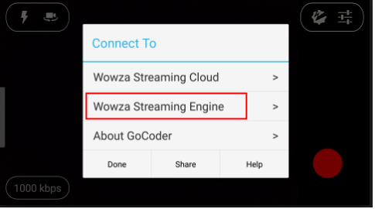

Access the wowza steam videos, touch the wowza icon in the app after that screen is appear for the details fill up:-

Touch the Wowza Streaming Engine,

1 Host option:- server ip like 202.145.152.24”It’s depend the wowza server local and public ip which wowza server is running” Port no :- 1935 “it’s by default for the access the wowza steam videos.

Then touch back

1. Application :- Appication Name :- webrtc1 “it’s depend which steam you want to run with wowza”. Steam Name:- Mysteam “steam name depend which type of steam name you want run” Then touch back
2. Source authentication :- Source Username :- john or [john@expmple.com](mailto:john@expmple.com) “it’s if it’s trial software the the email is mention here, which you received wowza key “. Source password :- *********. “it’s minimum 8 character and it’s depend what password you configure that time with wowza form fill up in the portal and get the access